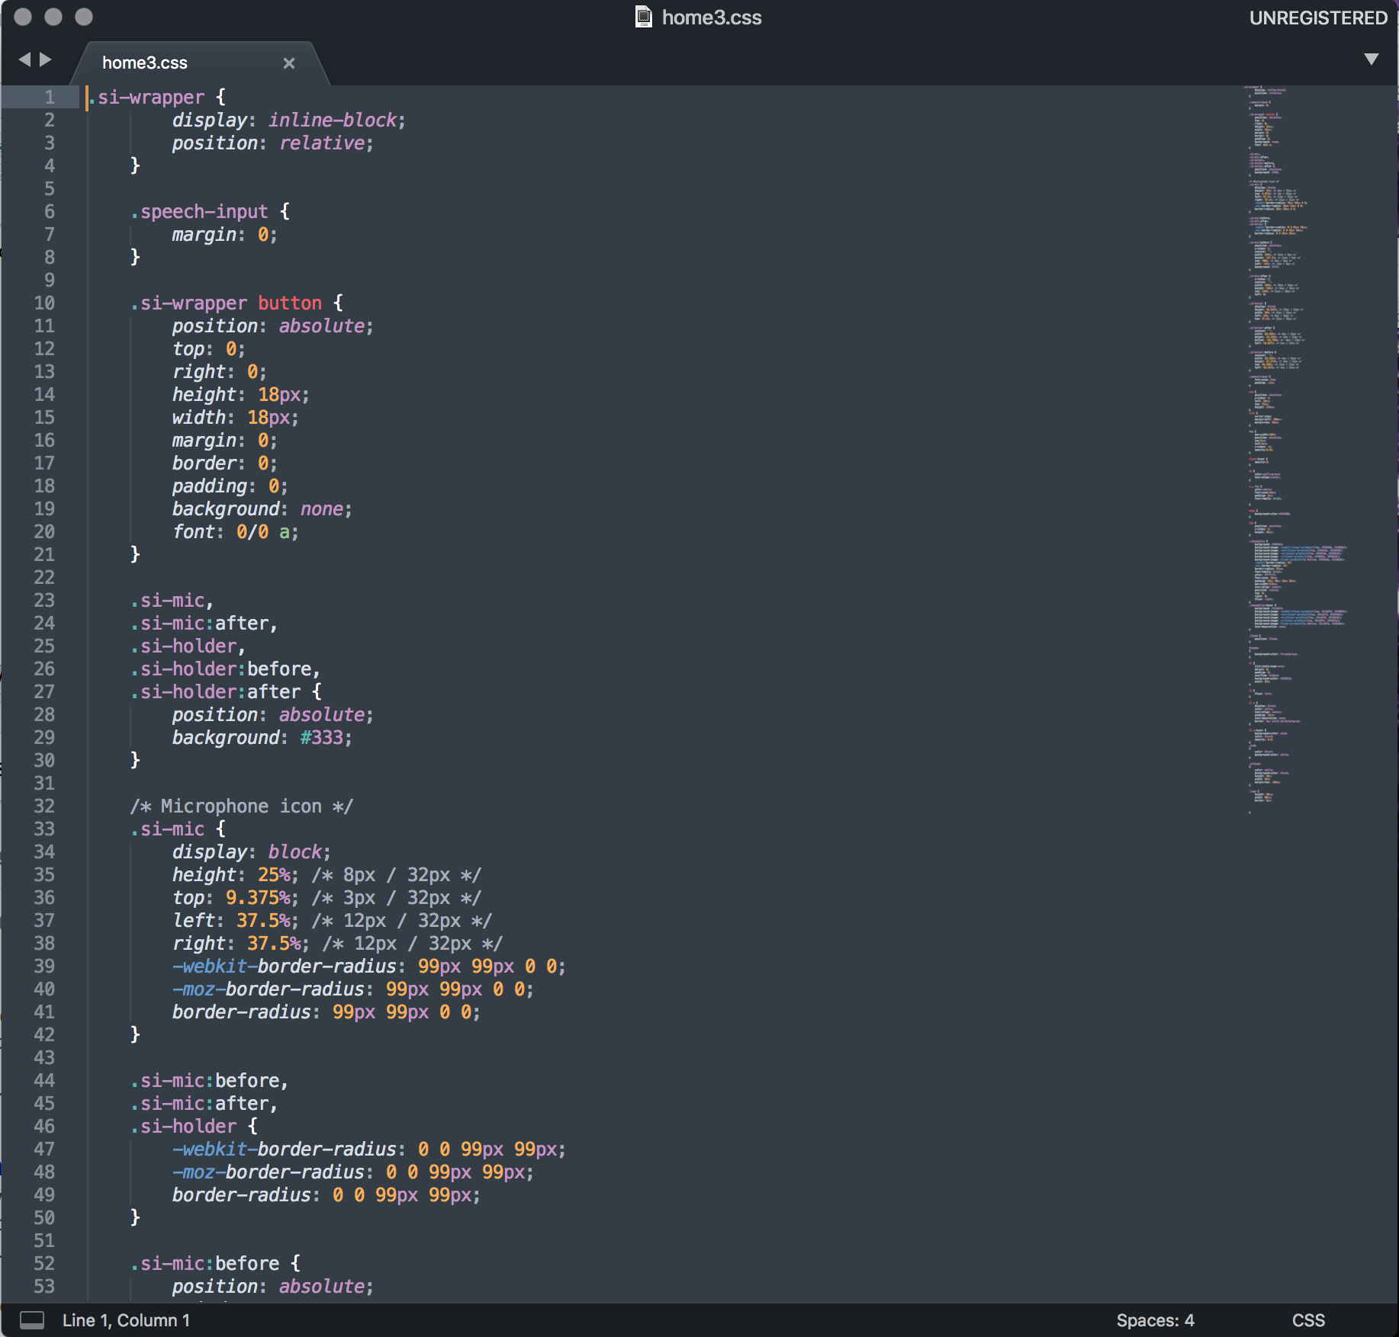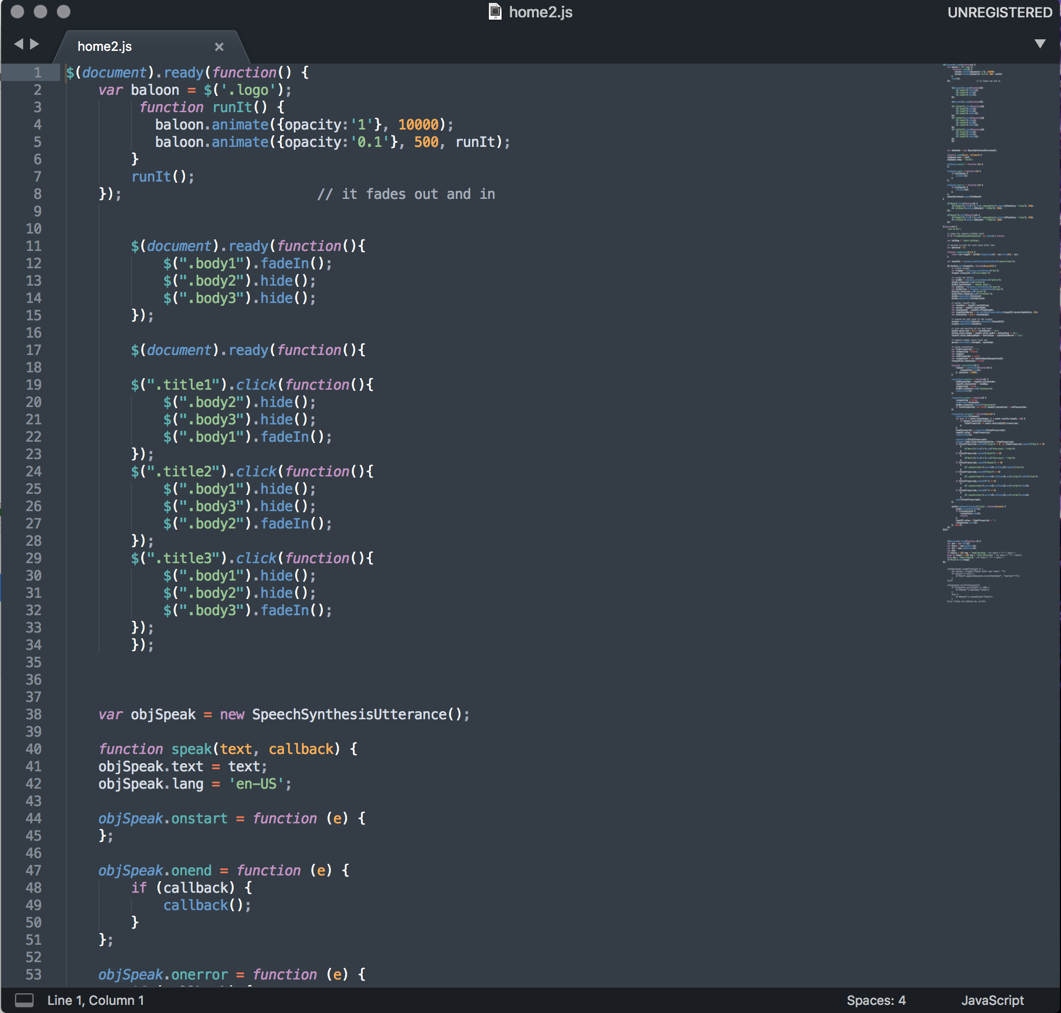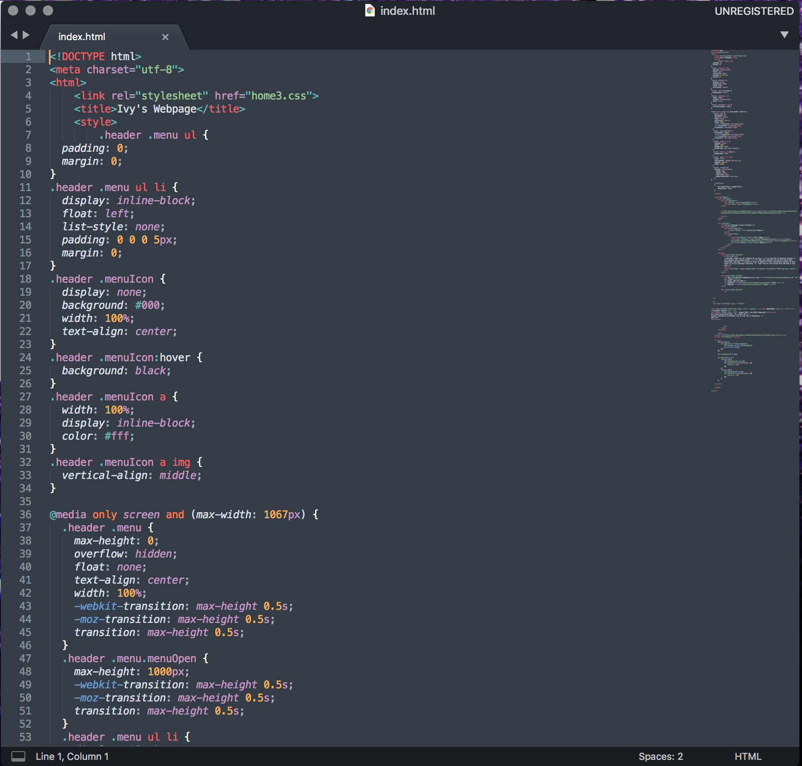

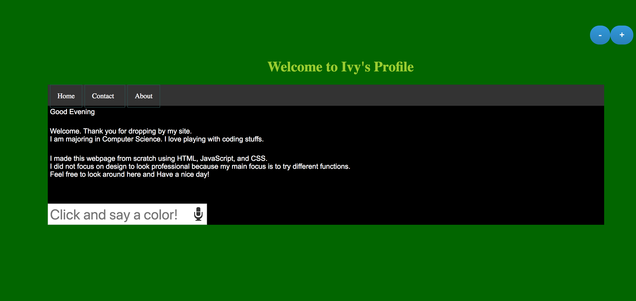

Please email me for the full codes which have lots of different functions.

[Ivy.heejung.seo@gmail.com](mailto:Ivy.heejung.seo@gmail.com)

Thank you so much for taking your time to check my work!